**FINANCE REPORT**

**8TH April 2025**

**CASHBOOK RECONCILLIATIONS**

Great Boughton Council started the financial year in April 2024 with £88,340.75 spread across the three bank accounts. At the 1st April 2025, I am pleased to report that the new financial year starts with a balance of £88,744.31.

Vicars Cross Community Centre started the financial year in April 2024 with a brought forward of £26,565.80 and starts the 2025 financial year with a balance of £24,999.70.

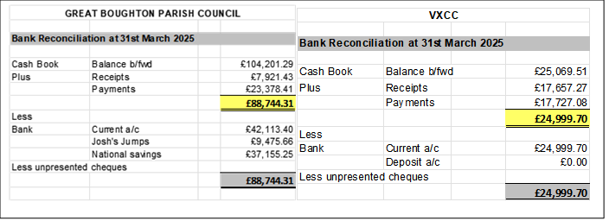

**BANK BALANCES**

|  |  |
| --- | --- |
| **GREAT BOUGHTON COUNCIL** | **VICARS CROSS COMMUNITY CENTRE** |
| Lloyds Current Account £140,258.87 | £25,893.99 |
| Jumps Reserve £9475.66 |  |
| National Savings Account £37,155.25 |  |

The following payments and receipts of over £100 have been made under delegated authority since 18th March (Bank statements are available on request from the Clerk)

07 Apr 25 CHESHIRE WEST 0 98,000.00

31 Mar 25 CHESTER HANDBOOKS 180.00

27 Mar 25 VICARS CROSS COMMU MARCH HALL HIRE 200.0

**FOCUS ON VICARS CROSS COMMUNITY CENTRE:**

The Community Centre continues to be a hub of activity with rooms being hired at weekends for a range of activities and regular bookings during the week remaining largely stable throughout the year:

* Regular room hire income for the last year totalled £27,243, whilst one off bookings (birthday parties etc gave an income of £6,969. The income from the hire of the meeting rooms has increased this year, resulting in a total of £6,737.
* The Centre has been successful in accessing £10,655 in grant income and there has been a further £3,895 in income from hiring the rear space for motorbike lessons, dog training etc.
* The centre costs around £10k per year to operate, this includes utilities, some minor maintenance, insurance, stationary, marketing etc and a further £18k approximately in staffing costs.

The community centre continues for the seventh consecutive year to “wash its face” and be financially viable without any revenue funding from the Council.

Sophia Samuel

8/04/2025