

Great Boughton Parish Council

Summary Receipts and Payments
Year Ended 31st March 2025

 | 2024 |  | INCOME |  | 2025
£ | 88,000.00 |  | Precept | £ | 92,500.00
£ | 406.32 |  | Bank Interest | £ | 500.38
£ | 4,808.49 |  | CIL Payments | £ | 1,909.37
£ | 33,838.59 |  | VAT Refund | £ | 18,693.11
£ | 2,414.20 |  | Rents | £ | 2,381.50
£ | 456.20 |  | Charged Services | £ | 325.58
£ | 362.05 |  | Miscellaneous | £ | 851.06
£ | 45,191.01 |  | VXCC Income | £ | 54,529.05
£ | 175,476.86 |  |  | £ | 171,690.05
 |  |  | EXPENDITURE
£ | 44,939.00 |  | Salaries | £ | 52,947.11
£ | 12,195.16 |  | Council Costs | £ | 9,692.71
£ | 4,298.47 |  | Facilities & Buildings | £ | 2,055.69
£ | 39,539.03 |  | Open Spaces | £ | 37,818.82
£ | 6,118.10 |  | Communications & Events | £ | 5,237.76
£ | 5,537.66 |  | Projects | £ | 13,321.60
£ | 36,185.20 |  | VXCC Running Costs | £ | 51,778.90
£ | 148,812.62 |  |  | £ | 172,852.59
£ | 148,812.62 |  |  | £ | 172,852.59

SUMMARY
Balance @ 31st March 2024 | £ | 114,906.55
Receipts to 31st March 2025 | £ | 171,690.05
 | £ | 286,596.60
Less
Payments to 31st March 2025 | £ | 172,852.59
 | £ | 113,744.01

Great Boughton Parish Council

Bank Reconciliation

Financial Year Ending 31 March 2025
Balance per Bank Statements as at 31/03/25:

 |  | £ | £
Balance per bank statements as at 31/3/25:
 | Parish Council Current Account | 42,113.40
 | Josh's Jumps Account | 9,475.66
 | NS&I Savings | 37,155.25
 | VXCC Current Account | 24,999.70
 |  |  | 113,744.01
Petty cash float (if applicable) |  |  | -
Less: any unpresented cheques as at 31/3/25
 |  |  | -
Add: any un-banked cash as at 31/3/25
 |  |  | -
Net balances as at 31/3/25: |  |  | 113,744.01

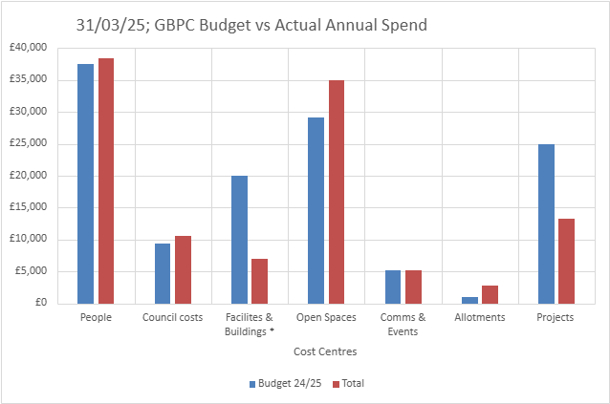
As at 31st March 2025; Great Boughton Council Budget vs Actual Annual Spend:
GBPC Summary Spend 24/25
 | Budget 24/25 | 1st Quarter | 2nd Quarter | 3rd Quarter | 4th Quarter | Total | % to Budget
People | 37,512 | 8,317.64 | 7,061.73 | 15,791.68 | 7,199.89 | £38,370.94 | 102%
Council costs | 9,378 | 3,944.34 | 3,373.38 | 1,964.19 | 1,327.79 | £10,609.70 | 113%
Facilities & Buildings | 20,000 | 192.28 | 699.11 | 5,405.33 | 758.97 | £7,055.69 | 35%
Open Spaces | 29,176 | 10,977.40 | 12,073.30 | 7,382.26 | 4,598.88 | £35,031.84 | 120%
Comms & Events | 5,210 | 202.48 | 2,111.19 | 2,414.49 | 509.60 | £5,237.76 | 101%
Allotments | 1,042 | 335.77 | 95.99 | 545.97 | 1,809.25 | £2,786.98 | 267%
Projects | 25,000 | 13,179.80 | 141.80 | 0.00 | 0.00 | £13,321.60 | 53%
Total: | £127,318 | £37,149.71 | £25,556.50 | £33,503.92 | £16,204.38 | £112,414.51 | 88%

GREAT BOUGHTON PARISH COUNCIL
Bank Reconciliation at 31st March 2025
Cash Book | Balance b/fwd |  | £104,201.29
Plus | Receipts |  | £7,921.43
 | Payments |  | £23,378.41
 |  |  | £88,744.31
Less
Bank | Current a/c |  | £42,113.40
 | Josh's Jumps |  | £9,475.66
 | National savings |  | £37,155.25
Less unpresented cheques
 |  |  | £88,744.31
As at 31st March 2025; VXCC Budget vs Actual Annual Spend:
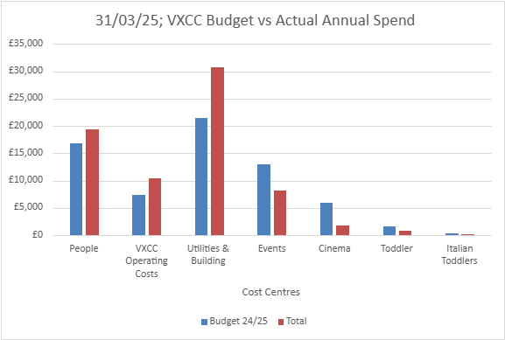

 | Budget 24/25 | 1st Quarter | 2nd Quarter | 3rd Quarter | 4th Quarter | Total | % to Budget
People | 16,800 | 4,020.22 | 5,569.92 | 2,966.44 | 6,878.59 | £19,435.17 | 116%
Operating Costs | 7,290 | 2,547.01 | 2,458.52 | 2,173.32 | 3,255.02 | £10,433.87 | 143%
Utilities & Building Maintenance | 21,450 | 3,971.57 | 6,139.18 | 14,301.85 | 6,274.14 | £30,686.74 | 143%
Events | 13,000 | 1,705.89 | 2,648.91 | 3,134.26 | 707.98 | £8,197.04 | 63%
Cinema | 6,000 | 199.70 | 553.90 | 495.24 | 442.99 | £1,691.83 | 28%
Toddler | 1,650 | 446.08 | 238.60 | 61.20 | 17.80 | £763.68 | 46%
Italian Toddlers | 350 | 70.00 | 0 | 0.00 | 0.00 | 70 | 20%
Total: | £66,540 | £12,960.47 | £17,609.03 | £23,132.31 | £17,576.52 | £71,278.33 | 107%

VXCC
Bank Reconciliation at 31st March 2025
Cash Book | Balance b/fwd |  | £25,069.51
Plus | Receipts |  | £17,657.27
 | Payments |  | £17,727.08
 |  |  | £24,999.70
Less
Bank | Current a/c |  | £24,999.70
 | Deposit a/c |  | £0.00
Less unpresented cheques
 |  |  | £24,999.70

